3rd Edition 2009
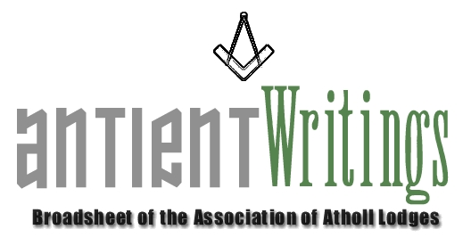

Extraordinary General Meeting

The Chairman convened an Extraordinary General meeting of the Executive Committee on 11th November to set in train plans to re-organise the workload and administration of the Association. The Secretary having brought forward his intention to ‘stand down’ precipitated the opportunity to reassess the workload that he had undertaken for the past 10 years. Therefore it was agreed that the workload be aligned, as per:

Secretary [Minutes/Notices/Agendas] - Dennis Mahoney – Tel: 0208 551 1651 – secretary@antients.co.uk
Liaison [Day to Day enquiries/Conduit] - Clive Moore – Tel: 0208 658 9194 – info@antients.co.uk
Merchandise [Sales Bar] - Dave Evans – Tel: 01424 732671 – sales@antients.co.uk
Antient Writings [Compiling/Distribution] - Don Roberts - Tel: 07950 418246 - news@antients.co.uk
Events Organiser [Visits/Planning/Trips] - Nominated per Event

The above email links will come into force in the near future when the web site is updated.
All other responsibilities remain unchanged. But should any keen member of an Atholl lodge be willing to offer any assistance please make contact. Help is always needed !

Annual General Meeting

The 2010 Annual General Meeting will be held at Freemasons Hall, Gt Queen Street, on Wed 14th July at 6pm. Notices of Motion must be received by the Secretary by 14th June. All are welcome to attend, volunteers especially.

Membership Secretary’s Appeal – Please renew your Subscription early

The 2010 renewals will soon be due. The fees are £10 for all categories and £5 for individuals. Terry will be pleased to receive payment early. He can be contacted at 6 St. Matthews Drive, St. Leonard’s on Sea, East Sussex, TN38 0TR. Tel: No. 01424 713004. Email: terrymahoney@btinternet.com

Web Site - www.antients.co.uk or webmaster@antients.co.uk and secretary@antients.co.uk

Please remember the dot com domain name was lost. We are now .co.uk [as above]

QuestionTime Event !

This Association’s QuestionTime event hosted by Kent Lodge No15. on October 14th was a great success. The eminent Panel was able and keen to answer all the questions submitted from the floor in an open and relaxed manner. Many interesting points were raised and answered on topics ranging from General to History to Esoteric.

Merchandise

Ties / Bow Ties / Lapel Pins are available from the website or Dave Evans who deals with sales on 0142 473 2671 david.evens3@sky.com They are £12.50 and £2.50 respectively. The book on the life of Laurence Dermott and the Antients is also available at £6 inc UK postage. You are permitted to wear Association ties at Atholl lodge meetings.

Would Secretaries and Representatives photocopy and distribute as widely as possible

Further Information please contact the liaison officer Clive Moore - 0208 658 9194

